**Context-specific interactions increase predictive power of network methods for identifying drug effects**

Jennifer L. Wilson1, Alessio Gravina2, Kevin Grimes1

1 Department of Chemical and Systems Biology, Stanford University, Stanford CA, USA.

2 Department of Computer Science, University of Pisa, Pisa, Italy.

**Summary**

In the face of high drug attrition, interaction network methods are increasingly attractive as quick and inexpensive methods for *in silico* predictions of potential drug effects compared. However, interaction networks associate a drug’s target proteins to many safety and efficacy phenotypes and selecting which phenotypes have clinical utility is challenging. Mathematical techniques that consider statistical enrichment or discovering an optimal distance between the drug’s target(s) and phenotype genes are relatively easy methods to apply yet they have high false positives rates. We hypothesized that interaction networks associated with true positives are context-specific and are poorly defined by a statistical or distance threshold. We tested this hypothesis on 21 severe adverse outcome phenotypes, or designated medical events (DMEs), and demonstrated that context-specific interactions (CSIs) distinguished true from false positives with an 1.5 improvement over mathematical approaches. DMEs are a subset of adverse events that are of upmost concern to FDA review of drug products and thus predictive methods for identifying these liabilities is of high priority for improving drug attrition. These results suggest CSIs are a viable approach for advancing network methods to have predictive capacity for regulatory review and selection of therapeutic targets.

**Introduction**

In the face of high drug attrition, network methods are increasingly attractive for understanding drug pharmacodynamic effects because these methods are high-throughput and inexpensive relative to experimental techniques. Many have applied network methods for understanding associations between drug target proteins and safety or efficacy phenotypes and extensions of these models have predicted drug repurposing opportunities1,2 and synergies for drug combinations3,4. These methods are compelling because a network approach may yield statistically significant associations for a drug’s protein targets to many more phenotypic associations than validated evidence exists. Due to financial or market competition, a drug may only be approved for one, maybe two disease indications, yet a network method might predict statistically significant associations to many more disease indications. These predictions may be opportunities for re-purposing or using drugs off-label yet distinguishing between true positives and true negatives remains a challenge, and gold standard sets of drug effects do not exist5.

The network community has applied multiple techniques for selecting between true positives and true negatives, each with varying advantages and disadvantages. Distance-based methods identify the number of protein-protein interactions to a reach a relevant phenotype association by calibrating to the distance between marketed drugs and their intend-to-treat disease1,6,7. Statistical enrichment methods look for enrichment of the network associations relative to associations across the entire interactome2 and some rank drug phenotypes based on the connectivity and closeness of phenotypes shared by drug combinations8. Neural network methods can achieve high accuracy at labeling known drug-drug interactions using protein-protein interaction networks, drug-target binding data, and gene/protein-phenotype data4. However, parsing the potential mechanism behind these predictions remains challenging. Here we compared three different methods for separating true positives and true negatives to better understand the trade-offs for prioritizing network selection methods.

We specifically considered network associations to drug side-effects because unintended drug side-effects are a major contributor to drug attrition and many applications of network methods have successfully identified drug associations to safety phenotypes. We reasoned that FDA regulatory review was a sufficiently stringent filter for identifying a true association between a drug and a side-effect and that a lack of a labeled warning was a sufficient filter for determining that a drug is *likely* not causative for a side-effect. Using this assumption, we defined a silver-standard set of positives using a natural language processing approach to extract drug-to-side-effect relationships from drug labels (publication forthcoming). This yielded a set of 1,136 drugs associated to 35 designated medical events (DMEs), a severe subset of drug side-effects. This dataset was originally developed and analyzed to understand network patterns between drugs with similar DME associations. However, the dataset provided a unique opportunity to assess the performance of network selection methods for a particular drug-phenotype prediction task. We defined a set of silver standard negatives as any of the 1,136 drugs that had network associations to this set of DMEs but the DME was not listed on the drug’s label. We further applied the PathFX algorithm2 because we could more easily modify the code base to test different methods for separating true positives and true negatives.

**Results**

*Statistical enrichment cannot clearly separate true positives and true negatives*

We first investigated a statistical enrichment method (**Figure 1A** and **Figure 2B**) for separating true positives and true negatives. Specifically, we used PathFX in its original published form. Briefly, PathFX uses a drug’s binding proteins as inputs to identify a network of relevant protein-protein interactions from a larger interactome network. The algorithm uses a database of gene-phenotype associations and statistical enrichment to identify enriched network phenotypes relative to the original interactome. We used PathFX to identify networks for all 1,136 drugs and investigated where PathFX identified a true positive – a network association between a drug and a DME on the drug’s label – and a false positive – a network association to a DME not listed on the drug label. The distributions for these p-values, both raw and normalized, overlap (**Supplemental** **Figure 1**), suggesting that a simple statistical test of enrichment is insufficient for separating true positives and true negatives. Not surprisingly, the area under the receiver operator curve (AUROC) is 0.54 (**Figure 3**).

*Using a distance-based approach does not increase model performance for DMEs*

We next investigated a simple distance metric for separating true and false positives (**Figure 1B** and **Figure 2B**). For this investigation, we modified PathFX from the original published form. Specifically, the original PathFX algorithm relied on an empirically derived path-score threshold to minimize common biases for network algorithms including hub-bias (a gene/protein has high connectivity because it is well studied) and annotation bias (a phenotype is associated with many network genes/proteins because it is overly studied). We considered this path score to be a sufficient proxy for interaction path distance, and so we created modified versions of PathFX using non-optimal distances (e.g. PathFX_dist0.9, PathFX_dist0.8, etc). We reanalyzed our 1,136 drug set using each of these distance algorithms and investigated how relaxing the path score value affected true and false positive rates (**Figure 3**). At distances of 0.82-0.99, we were unable to generate a full ROC curve. This is likely due to the fact that increasing interaction path distance can only yield more true positives if there are more genes associated with the phenotype of interest. We discovered that modifying the path score threshold did not increase an ability to detect true positive associations to DME-associated genes.

*Context-specific interactions increase network method performance*

Much of biology is context dependent and we hypothesized that a better separator of true and false positives could be the specific network genes/proteins supporting an association to a DME phenotype. To test this hypothesis, we tested multiple machine learning approaches to distinguish features associated with true positives and true negatives for each DME phenotype. We performed nested cross-validation to select among random forests, logistic regression, and decision trees and used the F1 statistic to discover that these methods were comparable in performance (**Figure 1C, Supplemental Figure 2, Supplemental Table 1**). We selected a simple linear regression because it was the most straightforward method for interpreting if and how network genes/proteins were associated with each DME of interest. Indeed, using a linear regression model combined with networks discovered for DME-associated drugs increased ROC values 1.5-fold above p-value or distance methods (**Figure 3**). Performance varied for each DME because a separate logistic regression model was required for each DME phenotype (**Supplemental** **Figure 2**).

CSIs are further attractive for their interpretability. For instance, applying linear regression to interaction networks discovered for drugs causative of edema, pneumonia, peripheral neuropathy, or tardive dyskinesia yielded a set of network genes correlated with true or false positive drug networks (**Supplemental Figure 4**). Further, meta-analysis of the interaction networks associated with positive and negative drugs identified mechanistic-like hypotheses about the differences between these associations (**Figure 4**). For instance, in the case of edema, regression coefficients identify both drug-binding and downstream intermediate network proteins that are most associated with edema phenotypes (**Figure 4**).

**Discussion**

Network selection methods are required for identifying relevant phenotypes associated with drug-binding proteins, however, each approach has advantages and disadvantages. Statistical enrichment is a tractable and relatively easy method to implement, because it requires the selection of a p-value threshold for considering a phenotype as “positive”. However, we discovered that statistical enrichment was unable to separate true positives from true negatives. It’s possible, but unlikely, that all of the predicted DME associations are in fact relevant to the drugs in this analysis, however interpreting the relevance of these predicted associations is limited because of the extent of overlap between true positive and true negative associations. Distance-based metrics are another attractive, and easily implemented approach for discovering associations between a drug’s targets and DME-associated genes. However, we were unable to universally apply a distance-based metric that correctly identified true positives without increase false positives. Further, Interaction distances at high path score thresholds can be considered synonymous with only analyzing the drug’s targets. An inability to detect DME associations using only drug targets further motivates the use of network methods for DME detection. We discovered that machine learning techniques – specifically a simple logistic regression model – could identify network proteins for each DME and these interaction-based classifiers could separate true positives and true negatives across DMEs. This suggests that a knowledge of the context-specific protein-protein interactions is a valid approach for identifying relevant phenotypes from interactome networks.

We acknowledge limitations in this analysis. For instance, the definition of a set of gold-standard true negative examples is imperfect. We considered the lack of a warning on a drug’s label as a sufficient standard for our analysis, considering the rigor and integrity of the FDA review process. Yet, it’s still possible that some of our true negatives are false negatives and could have a meaningful association to a DME despite a lack of a labeled warning. Because defining gold standard true negatives is difficult, our analysis is limited to the investigation of DMEs and does not consider drug efficacy. Understanding how well interaction pathways associate drug targets to efficacy phenotypes would require greater transparency about ‘failed’ tests of drugs against multiple diseases and better curation of this type of data. Further, the current definitions of CSIs could be further optimized. For some DME contexts, we achieved AUROC values that were much higher than p-value or distance-based metrics. For some DME contexts, we were unable to build sufficiently predictive models and ultimately restricted analysis to DMEs where we had at least 10 positive and negative examples. These models could be improved by further curation of positive and negative examples or the inclusion of more data (e.g. drug-protein binding data, gene-DME associations, or protein-protein interactions).

We acknowledge that a major limitation in this approach is the requirement of known effectors. Specifically, to more correctly associate a drug with a relevant effect on a DME, we need several examples of drugs that effect the DME to sufficiently train a classifier. This limits the ability to predict relevant drug effects on novel, or underdeveloped phenotypes (e.g. diseases for which there are not existing established therapies). In the case of DMEs, sufficient drug effectors existed for training classifiers, making context-specific analysis feasible for classifying the effects of new compounds on DMEs. We anticipate opportunities for using data from established assays and model systems to mine CSIs for drug-efficacy related phenotypes, especially for disease areas where successful therapies do not yet exist. We anticipate that network selection methods relying on mathematical principles (e.g. p-value selection, network distance, network connectivity) will remain as powerful workhorse techniques, especially in contexts where known drug effectors are not established. We see CSI mining as a means to advance these predictions towards the goal of providing predictive power for decision-making at the level or regulatory review or industrial selection of gene targets for new therapies.

The contribution in this work is the demonstration that prioritizing specific subsets of the interaction network can be predictive for modeling drug effects. From a network engineering perspective, CSI mining may indeed affect how network methods are developed for understanding drug mechanisms. This result presented here encouraged us to pursue further validation of the prioritized network proteins as mediators of drug mechanisms. Indeed, combination drugs that bind DME-network proteins synergized to affect adverse outcomes associated with drugs associated with the DME on their drug labels (submitted). Together, these results suggest a paradigm shift towards network engineering of context-specific pathways to identify drug network mechanisms.

**Methods**

*Extracting true positive and true negative drug examples from drug labels*

We extracted relevant phenotypes from the drug’s labels using a custom NLP query (publication forthcoming, data included in *Drugs_labeled_for_AEs.txt*). We further refer to ‘positive drug examples’ as those drugs associated with a DME on their drug label. We refer to ‘negative drug examples’ as any of the 1,136 drugs in our drug set that do not have a DME listed on their drug label. We define positives and negatives for each DME separately. For instance, 496 drugs are associated with myocardial infarction on their drug label, and these drugs are considered positives for the myocardial infarction DMEs. The remaining 640 drugs in our 1,136 drug set are considered negatives for the myocardial infarction DME.

*Modeling true positive and negative networks with PathFX*

We analyzed 1,136 drugs using PathFX with default parameter settings. Briefly, PathFX uses drug-binding proteins as inputs to first identify a relevant protein-protein interaction network around these targets, and second uses the full list of network genes/proteins to identify phenotypes associated with these genes/proteins relative to the entire interactome. For each drug, PathFX analysis yielded interaction networks and a list of phenotypes associated with these networks. For a full list of features and outputs, see2,9.

We assessed whether a phenotype matched a DME from the drug label and considered these pairs as true positives. We also searched these same association tables for DMEs not listed on the drug’s label and considered these as false positives. The script *define_tp_fp.py* creates the following outputs: *drugs_to_dmes_true_positive.txt, drugs_to_dmes_false_positives.txt*.

*Plotting p-value distributions and estimating AUROC values*

In the same script (*define_tp_fp.py* ) where we defined our true and false positive examples, we generated plot of the p-values for these associations. This script generates the plots, *raw_pvalues.png*, and *norm_pvalues.png*, and generates the data object, *pvalue_roc_values.pkl*, for further analysis. We analyzed the AUROC in the script, *plot_ROC_pv_soDist.py*, using the trapez method implemented in Python.

*Measuring the effect of interactome distance on detecting DME associations*

We developed modified versions of PathFX to test the effect of altering interaction distance on detecting associations to DMEs. For the original PathFX construction we empirically derived an interaction score threshold to prevent hub bias2. To measure the effect of interactome distance on detecting associations, we created 11 custom versions of PathFX. These scripts are contained in the *PathFX_soDist/scripts*/ directory and are named *phenotype_enrichment_pathway_so_dist_0.82.py* where ‘0.82’ represents the score threshold used in this version. The other score thresholds used include 0.82-0.90, 0.95, and 0.99. We used these thresholds out of convenience. We started our experiment using a stringent, high threshold, and then relaxed this threshold to increasingly allow more edges to be considered in network construction. Given the score distribution of our interaction network, we found that computational time increased significantly as we reached the 0.82 range. We truncated the analysis with this version because we saw that we were no longer drastically changing our ability to detect more true positives.

We created networks for our 1,136 drug set using each version using the script *run_pathfx_all_distances.py*. This script generated networks, and association files for all 1,136 drugs at each of the 11 distances. We investigated whether the networks for these drugs contained associations to true or false positive DMEs at each score threshold. We analyzed these results using the script, *count_tp_fp_so_dist.py*, and the results of this script are saved in the *PathFX_soDist/results/analyze_so_dists/* directory. We then used the *plot_ROC_pv_soDist.py* to count the true and false positive rates at each score threshold and plot the ROC curve using these values. This script generates *the pvalue_ROC_dist.png* figure.

*Logistic regression, decision trees, and random forests analysis*

For this analysis, we created binary vectors for all true and false positive networks associated with a DME. These vectors included a 1/0 if a gene was/was not included in the drug’s network respectively. Rows were labels as positive if the drug’s label included the DME on the label or negative if the drug’s label was not associated with the DME. This analysis is included in the script *create_positive_negative_files.ipynb* and this analysis yielded a matrix file for each of 24 DMEs: agranulocytosis, cardiac arrest, cerebral infarction, deep vein thrombosis, delirium, edema, gastric ulcer, hemolytic anemia, hemorrhage, hepatic necrosis, hyperlipidemia, hypertension, interstitial lung disease, myocardial infarction, myopathy, pancreatitis, peripheral neuropathy, pneumonia, proteinuria, pulmonary edema, sepsis, tardive dyskinesia, thrombocytopenia, and ventricular tachycardia. These files are saved in */ML_network_positives_negatives/dme_DMENAME.txt* where DMENAME is replaced with each of the DMES of interest.

We first used the scikit-learn module in python and a nested cross-validation procedure to evaluate modeling types – logistic regression, decision trees, and random forest – and used the F1 score to evaluate model performance in this analysis (*ML_network_positives_negatives/run_all_dme_models_ncv.py*). The results of those analysis are included in **Supplementary Figure 1**. To generate test scores for the ROC curves using logistic regression, we modified *ML_network_positives_negatives /run_all_dme_models_new_log_reg.py* and *ML_network_positives_negatives/all_pathways.py* scripts. To plot all ROC curves, we used *plot_ROC_all_methods_072720.py*.

*Plotting merged networks*

To create merged networks and shading with logistic regression coefficients, we used *add_python_script_here.ipynb*.

*Data and code availability*

The data and code used in this analysis are available on GitHub (https://github.com/jenwilson521/network_selection).

**Acknowledgements**

JLW was partially and AG and KG were supported by the SPARK program at Stanford. JLW was also supported by a Sanofi iDEA Award.

**Author Contributions**

JLW conceived of the idea. JLW and AG conducted the analysis. JLW wrote the manuscript. JLW, AG, and KG revised the manuscript.

**References**

1. Guney, E., Menche, J., Vidal, M. & Barabási, A.-L. Network-based in silico drug efficacy screening. *Nat Commun* **7,** 10331 (2016).

2. Wilson, J. L. *et al.* PathFX provides mechanistic insights into drug efficacy and safety for regulatory review and therapeutic development. *PLoS Comput Biol* **14,** e1006614–27 (2018).

3. Yoo, S. *et al.* In silico profiling of systemic effects of drugs to predict unexpected interactions. *Nature Publishing Group* **8,** 1612 (2018).

4. Zitnik, M., Agrawal, M. & Leskovec, J. Modeling polypharmacy side effects with graph convolutional networks. *Bioinformatics* **34,** i457–i466 (2018).

5. Harpaz, R. *et al.* A time-indexed reference standard of adverse drug reactions. *Scientific Data 2017 4:null* **1,** 140043–10 (2014).

6. Aguirre-Plans, J. *et al.* Proximal Pathway Enrichment Analysis for Targeting Comorbid Diseases via Network Endopharmacology. *Pharmaceuticals* **11,** 61–18 (2018).

7. Cheng, F., Kovács, I. A. & Barabási, A.-L. Network-based prediction of drug combinations. *Nat Commun* **10,** 1–11 (2019).

8. Sanders, J. M. *et al.* Informing the Selection of Screening Hit Series with in Silico Absorption, Distribution, Metabolism, Excretion, and Toxicity Profiles. *J. Med. Chem.* **60,** 6771–6780 (2017).

9. Wilson, J. L. *et al.* PathFXweb: a web application for identifying drug safety and efficacy phenotypes. *Bioinformatics* **11,** 265–4506 (2019).

**Figures**

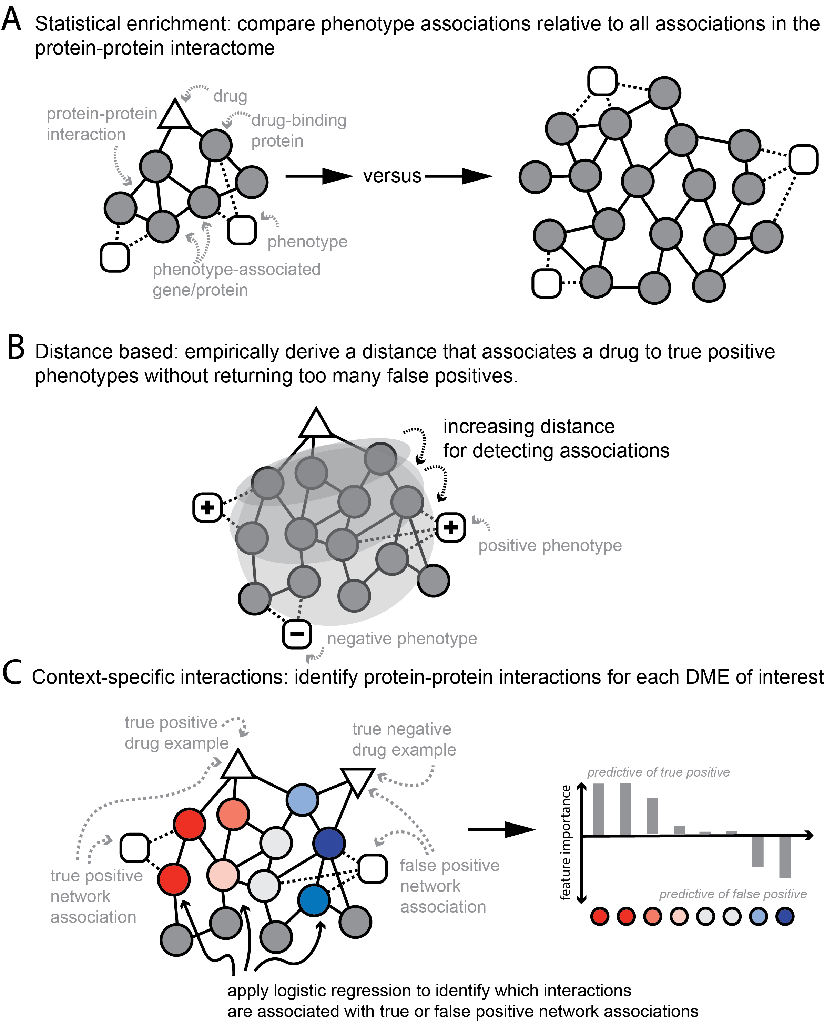

**Figure 1. Theoretical overview of methods tested**. In statistical enrichment, a network association is selected if the drug’s interaction network is enriched for associations to a phenotype of interest relative to the entire interactome (**A**). In a distance-based analysis, an interaction distance is calibrated based on the ability to identify relationships to true positive phenotypes without finding associations to true negative phenotypes (**B**). In a context-specific interactions analysis, machine learning techniques (e.g. logistic regression) are applied to discover which genes/proteins and interactions separate true from false positives. The set of genes/proteins and interactions are specific to a phenotype of interest whereas a distance or enrichment method is generalized across phenotypes (**C**).

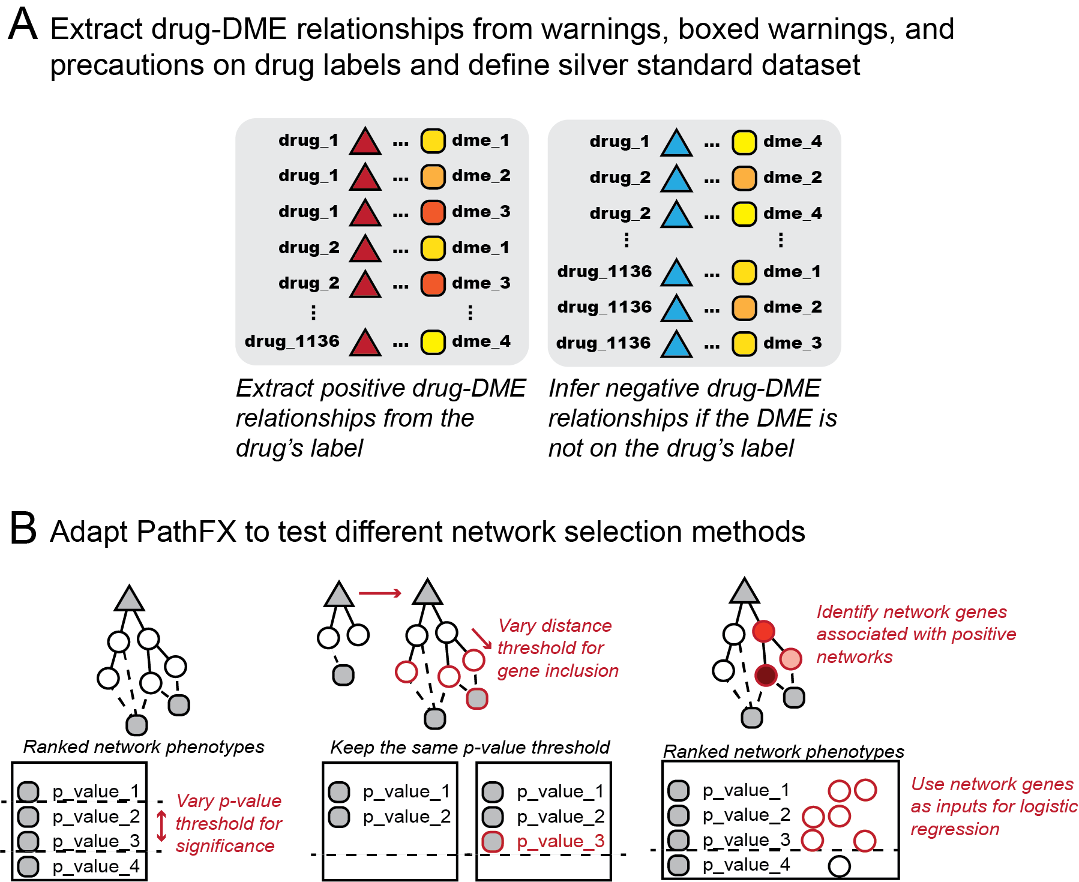

**Figure 2. Adaptation of PathFX for testing of theoretical methods**. Positive Drug-DME relationships are extracted from the warnings, boxed warnings, and precautions section of the drug’s label. Negative cases (or cases where the drug is not expected to cause the DME) are inferred from the absence of the DME on the drug’s label (**A**). To test various theoretical approaches, we adapted PathFX in three ways: first we constructed networks using the optimal distance threshold derived in {Wilson:2018ko} and then varied the p-value threshold used to select associations discovered by PathFX (**B**, left); next we generated multiple versions of PathFX using sub-optimal distances to explore whether a stringent or relaxed search of the network would correctly associate a drug’s targets to relevant DMEs (**B**, middle); lastly, we used PathFX with the distance and p-value thresholds derived in {Wilson:2018ko} and then analyzed DME-associated network genes with subsequent machine-learning methods (**B**, right).

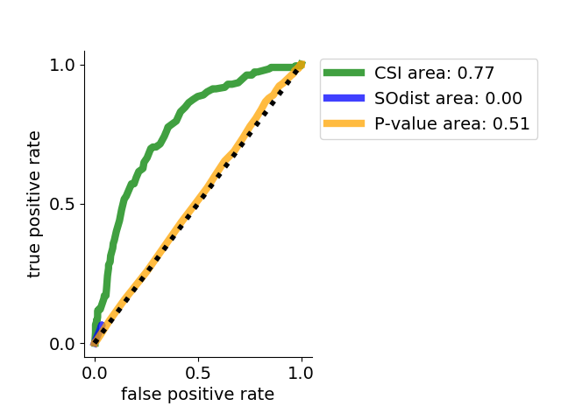

**Figure 3. Area under the receiver operator curve (AUROC) for three network methods shows increased performance of context-specific interactions (CSIs).** ROC curves for distinguishing true and false positives using p-value (orange) or a distance-based approach (blue) or using CSIs (green).

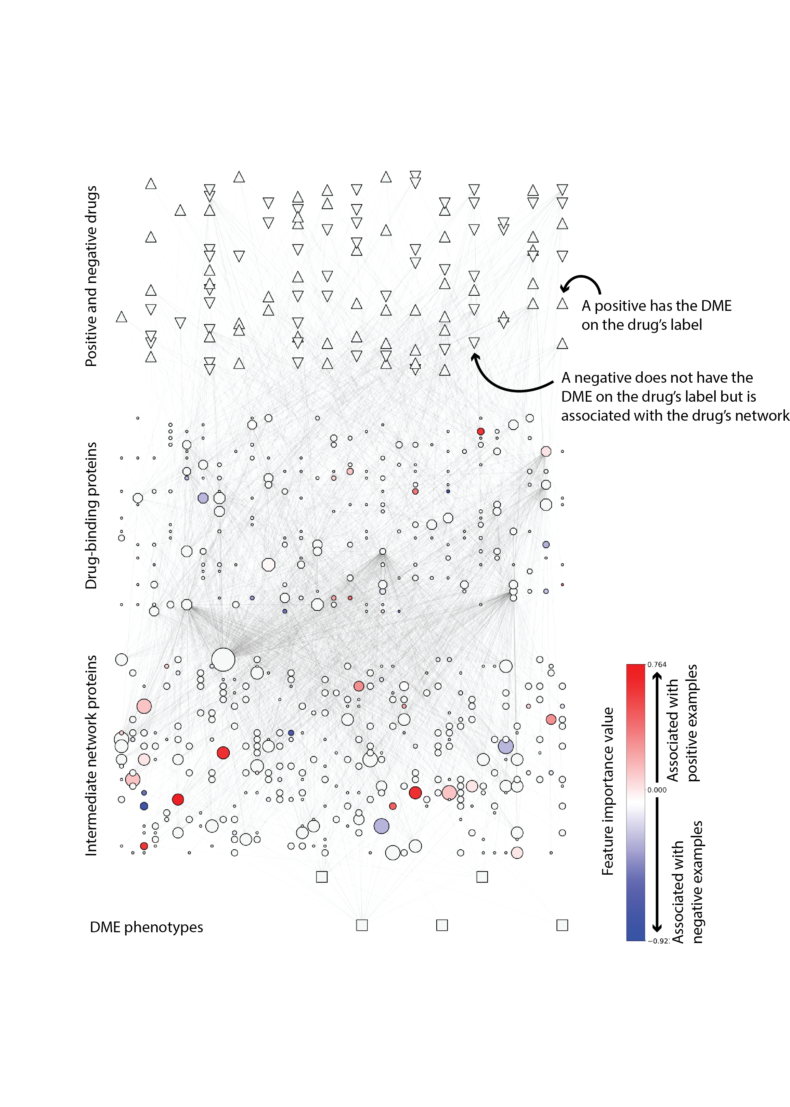

**Figure 4. Meta-analysis of DME-associated networks identifies CSIs for edema.** The merged interaction network for all true and false positive drugs associated with edema highlights which network components – drug-binding and network proteins – are contributing to the logistic regression model. True/false positive drugs are represented in the top layer as regular/inverted triangles respectively. Drug-binding and intermediate pathway proteins are represented in the second and third layers. The size of the protein reflects the number of networks in which the protein appears. Relevant edema-associated phenotypes are represented as boxes in the last layer. Protein coloring reflects the feature importance in the logistic regression model. Red/blue coloring represents association to true/false positive networks.

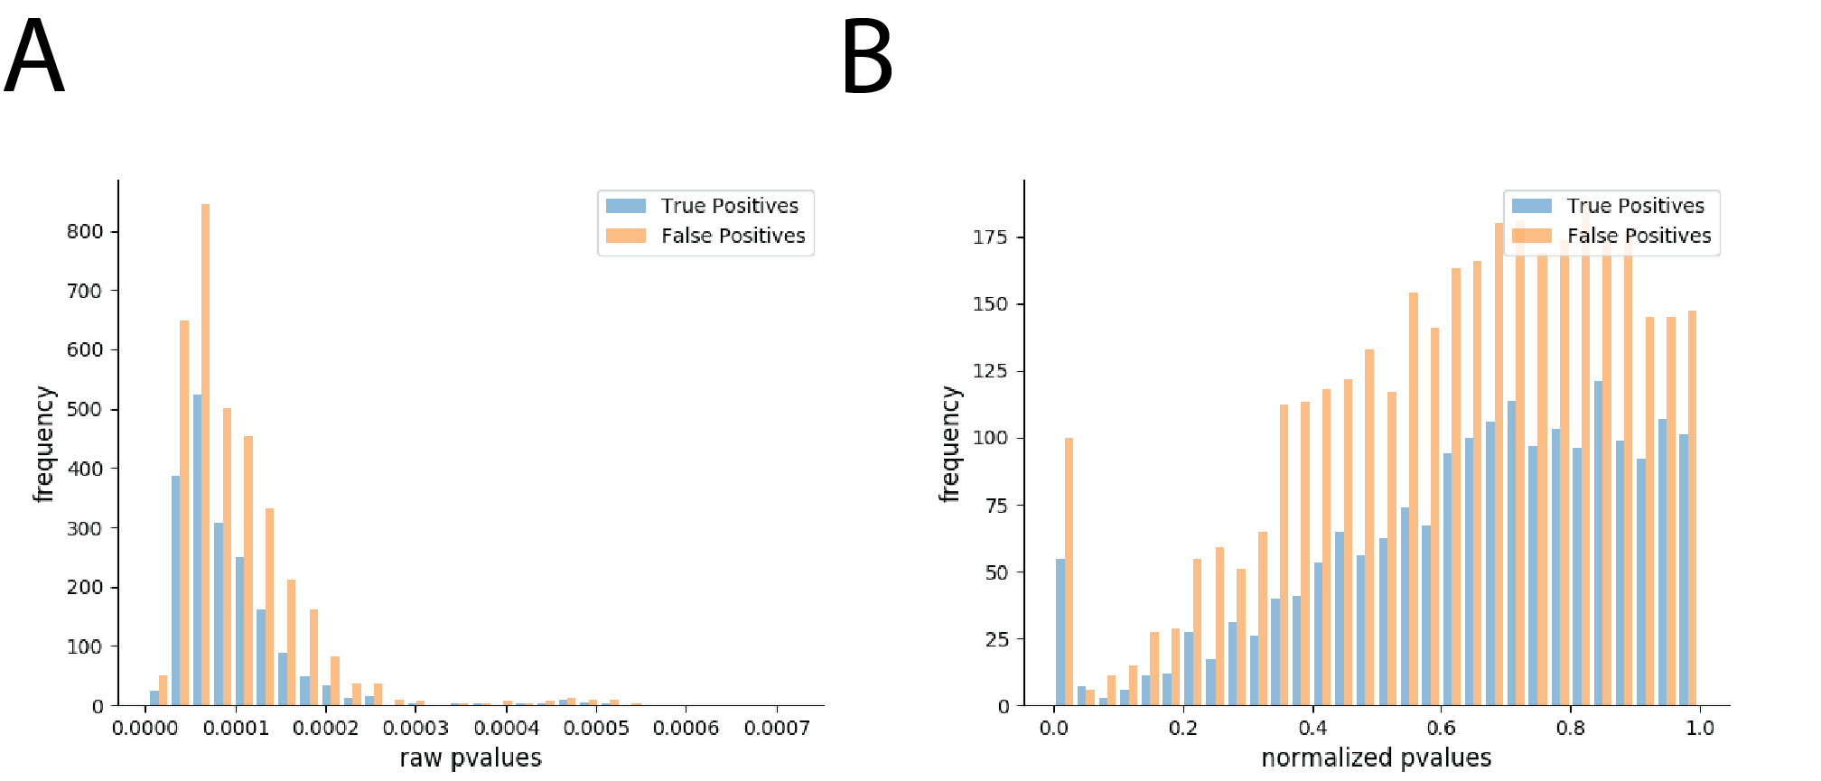

**Supplemental Figure 1**. **Comparison of raw and normalized p-values for true positives and false positives**. (**A**) Distribution of p-values for true and false positive drug associations to DMEs. (**B**) Distribution of normalized p-values for true and false positive drug associations to DMEs.

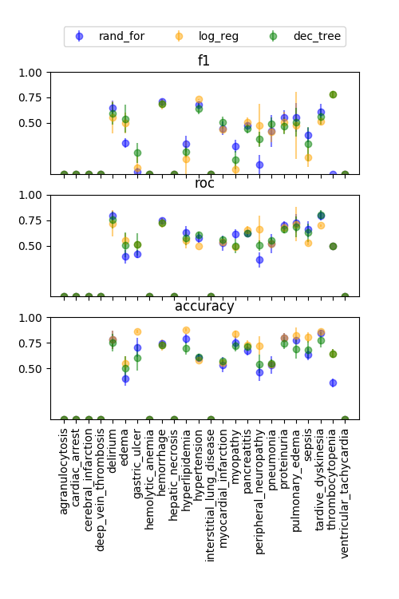

**Supplemental Figure 2. Performance of three modeling approaches using nested cross validation analysis**. We applied a nested cross validation approach using decision trees (green), random forests (blue), and logistic regression (orange) for 16 DMEs. The remaining 8 DMEs were skipped because they had fewer than 10 positive or 10 negative cases and we considered this to bias the model. We assessed model performance by F1, ROC, and Accuracy scores. Error bars represent the standard deviation of XX splits of the data.

|  |  |  |  |
| --- | --- | --- | --- |
|  | **ROC** | **F1** | **Accuracy** |
| dec_tree | 0.6042 | 0.4639 | 0.6560 |
| rand_for | 0.5983 | 0.4321 | 0.6487 |
| log_reg | 0.5954 | 0.4380 | 0.7297 |

**Supplemental Table 1. Average ROC, F1, and Accuracy scores for DMEs used in nested cross-validation**. Note: As described in Supplementary Figure 1, we did not perform model assessment for any cases where we had fewer than 10 positive or fewer than 10 negative cases.

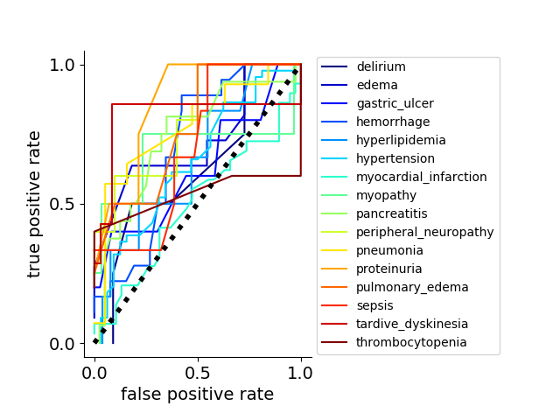

**Supplemental Figure 3. ROC curves for all DMEs.** ROC curves are plotted for all models including p-value (blue), distance (orange), and 21 DME logistic regression models (shades of purple).



**Supplemental Figure 4. Network genes correlated with positive DME networks.** Top feature importance values for network genes associated with positive drugs. Feature importance values were filtered for those values above the 50% max positive correlation or less than 50% of the negative correlated genes. A positive/negative value indicates the gene was associated with true/false positive networks. Top and bottom genes are shown for edema (**A**), peripheral neuropathy (**B**), pneumonia (**C**), and tardive dyskinesia (**D**).